Day 31 — 2:1 Multiplexer Using Verilog HDL

Introduction: A 2:1 Multiplexer (MUX) is a combinational circuit that selects one of two inputs and sends the selected input to the output.
- I0 → Input 0
- I1 → Input 1
- S → Select line
- Y → Output

Equation Y=SI0​+SI1​

Operation:
S = 0 → Y = I0
S = 1 → Y = I1

Gate-Level Modeling: The MUX is implemented using NOT, AND, and OR gates according to the Boolean equation..

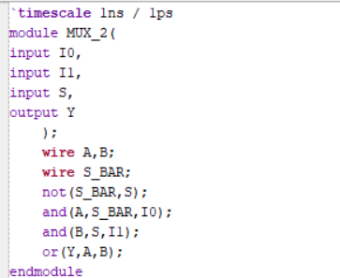

Dataflow Modeling: The MUX functionality is implemented using a continuous assign statement based on the Boolean equation.

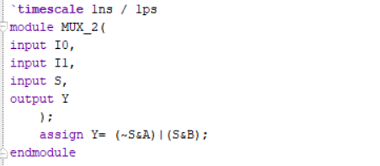

Behavioral Modeling: The MUX functionality is implemented using an if-else statement based on the select input.

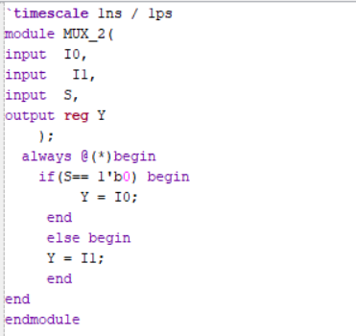

Testbench: A testbench was created by applying different combinations of I0, I1, and S. The output Y was observed to verify the selection operation.

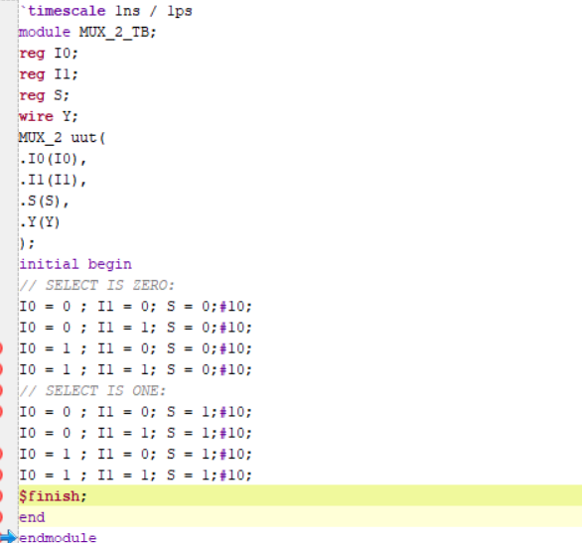

Waveform: The simulation waveform was observed for I0, I1, S, and Y.
When S = 0, Y follows I0, and when S = 1, Y follows I1.
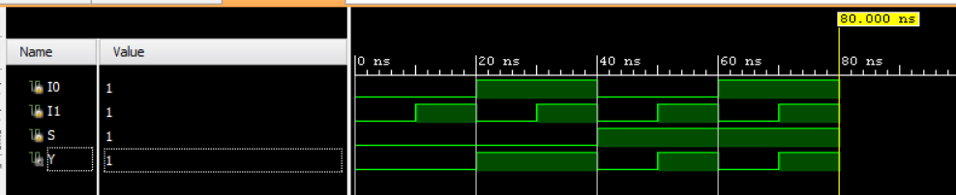

Schematic:
The RTL and Gate-Level schematics were generated in Xilinx Vivado to verify the hardware implementation of the 2:1 MUX.
GATE LEVEL:
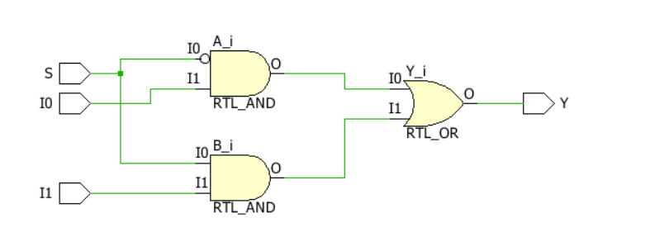

BLOCK LEVEL:
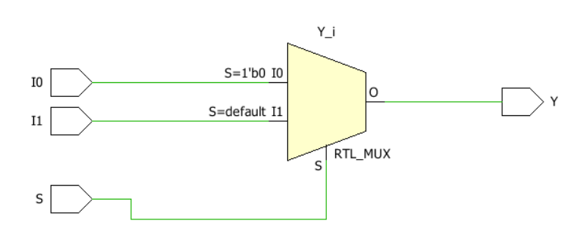

Observation
The 2:1 Multiplexer was successfully designed and verified using Gate-Level, Dataflow, and Behavioral modeling in Verilog HDL. The simulation confirmed that the output correctly follows the selected input.

